WAZUH Tutorial: Introduction, Setup, and Example Use Cases

Wazuh is a free and open-source security platform that provides unified Security Information and Event Management (SIEM), threat detection, incident response, and compliance monitoring.
It helps monitor:
- Log data from endpoints
- File integrity changes
- Vulnerabilities and malware
- Network-based attacks
Wazuh is composed of three main components:
- Wazuh Manager – collects, processes, and analyzes security data
- Wazuh Agent – installed on monitored endpoints to collect logs
- Wazuh Dashboard – web interface (based on Kibana) to view alerts and reports
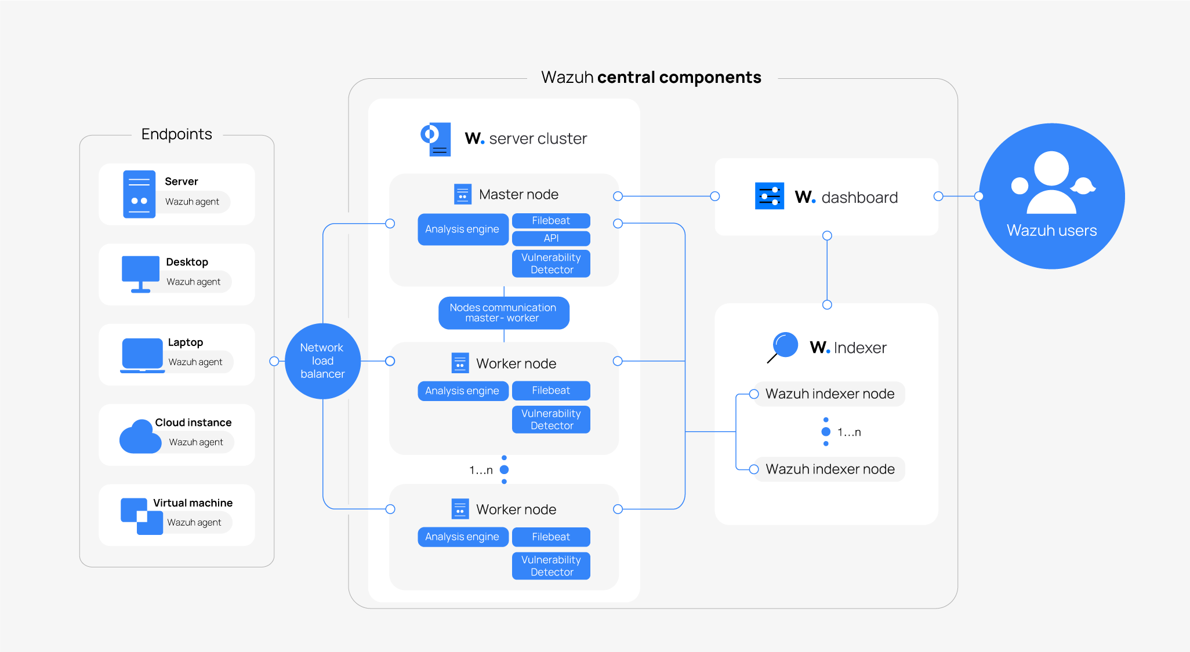
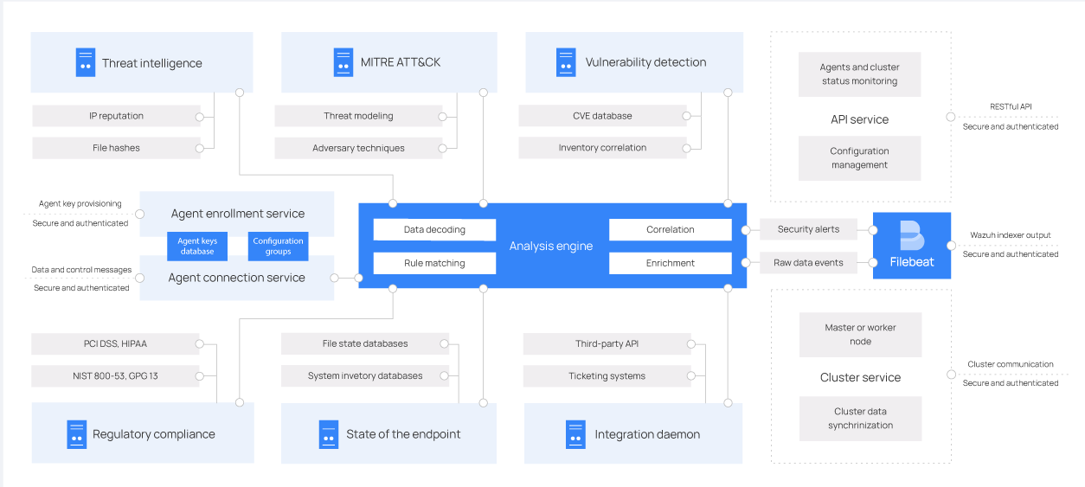
Wazuh Use Cases
- Intrusion Detection: Detects suspicious login attempts, brute force, or command injections
- Log Collection and Analysis: Parses logs from Apache, SSH, Suricata, etc.
- File Integrity Monitoring (FIM): Alerts when sensitive files are modified
- Regulatory Compliance: Supports PCI-DSS, HIPAA, GDPR, NIST, and more
- Threat Intelligence Integration: Enrich alerts with threat feeds (OTX, VirusTotal)

🧠 Wazuh Architecture and Core Components
Wazuh operates as a modular and scalable security platform composed of several key components, each responsible for different parts of the detection and monitoring lifecycle.
1. Wazuh Manager
- Central brain of the Wazuh platform.
- Receives and processes data from agents.
- Applies rules and decoders to generate alerts.
- Sends parsed alerts to the indexer.
Example: When a Wazuh agent sends SSH login activity, the manager uses decoders to parse the log and rules to identify brute force patterns. If 5 failed logins occur in 2 minutes, the manager raises an alert.
2. Wazuh Agent
- Lightweight software installed on monitored endpoints (Linux, Windows, macOS).
- Collects system logs, monitors files, checks for vulnerabilities.
- Forwards this data to the manager for correlation.
Example: On an Ubuntu server, the Wazuh agent detects changes in /etc/passwd and forwards a syscheck alert to the manager.
3. Wazuh Indexer (formerly Elasticsearch)
- Stores and indexes alerts received from the manager.
- Enables fast searching, aggregation, and analytics.
- Powers the data backend for the dashboard.
Example: A security analyst runs a query for "CVE" and gets all systems affected by critical vulnerabilities reported by the manager.
4. Wazuh Dashboard (Kibana-based UI)
- Web-based interface to visualize alerts, system status, compliance, etc.
- Includes modules for threat hunting, vulnerability view, file integrity, PCI-DSS, and more.
Example: An analyst sees a real-time alert labeled PCI-DSS 10.2.5 indicating an unauthorized file access event on a monitored system.
5. Filebeat (Optional)
- Ships manager logs to the indexer for ingestion.
- Useful in distributed environments.

🔍 Functionalities of Wazuh (With Examples)
🔐 1. File Integrity Monitoring (FIM)
Detects changes to critical files (e.g., /etc/passwd)
Example:
- Agent monitors /etc
- Admin modifies /etc/hosts
- Wazuh generates an alert labeled syscheck with severity level
👥 2. User and Rootkit s and checks for rootkits using its active response and syscollector modules.
Example:
- Unusual login at 3AM from an unknown user triggers sshd alert
- Dashboard shows login IP, user, time
🚨 3. Intrusion Detection and Log Monitoring
Integrates with applications like Apache, SSH, and Suricata.
Example:
- Suricata logs are parsed by Wazuh agent from /var/log/suricata/eve.json
- Alerts show signatures like "SYN Flood Detected"
⚙️ 4. Vulnerability Detection
Using the vulnerability detector module, Wazuh correlates OS/software versions against known CVEs.
Example:
- Outdated OpenSSL detected
- Alert shows CVE-ID and severity (e.g., CVE-2023-9999, severity 9.8)
📋 5. Regulatory Compliance
Wazuh supports mapping alerts and configurations to frameworks like:
- PCI-DSS
- HIPAA
- GDPR
- NIST 800-53
Example:
- PCI-DSS compliance dashboard highlights password policy violations

Step 1: Download and install the agent on the client machine
curl -sO https://packages.wazuh.com/4.7/wazuh-agent-4.7.2.deb
sudo dpkg -i wazuh-agent-4.7.2.deb
Step 2: Register the agent with the manager
sudo /var/ossec/bin/agent-auth -m <WAZUH-MANAGER-IP> -A <agent-name>
Step 3: Start the agent
sudo systemctl enable wazuh-agent
sudo systemctl start wazuh-agent

🔍 Example: Detecting Unauthorized File Changes
- On the client system (agent), enable file integrity monitoring in:
sudo nano /var/ossec/etc/ossec.conf
Add inside <ossec_config>:
<syscheck>
<directories check_all="yes">/etc,/home</directories>
</syscheck>
- Restart the agent:
sudo systemctl restart wazuh-agent
- Modify a file:
echo "unauthorized" >> /etc/passwd
- Check alerts in Wazuh dashboard → Security Events → syscheck

📈 Visualizing Alerts
- Go to Threat Hunting
- Use filters like:
data.alert.level:[8 TO 15]
- View categories like:
  - malware
  - sshd
  - suricata
  - syscheck

🧩 Additional Functional Modules in Wazuh (Advanced Examples)
🗃️ 6. Log Data Collection and Custom Parsing
Wazuh uses decoders and rules to parse custom logs from any source.
Example:
- You configure Wazuh to monitor /var/log/nginx/access.log
- Wazuh parses failed HTTP requests and generates alerts for 403/404 codes
🚫 7. Active Response
Wazuh can automatically react to suspicious behavior by executing scripts (e.g., block IP).
Example:
- Too many failed SSH logins from 192.168.1.100
- Wazuh executes a firewall command to drop that IP via active response
🔐 8. MITRE ATT&CK Mapping
Wazuh maps many of its detection rules to MITRE ATT&CK tactics and techniques.
Example:
- A rule matches brute-force activity → Wazuh assigns it T1110 (Credential Access)
- Viewable in Dashboard > ATT&CK Matrix
🧾 9. Cloud and Container Monitoring
Wazuh can monitor Docker, Kubernetes, and cloud services like AWS using agentless methods or cloud APIs.
Example:
- Wazuh ingests AWS CloudTrail logs and alerts on IAM privilege escalations
📜 10. Centralized Configuration and Agent Management
From the Wazuh dashboard, you can:
- Remotely restart agents
- Push new configuration files
- Trigger integrity checks
Example: You apply a centralized syscheck configuration to 50 Linux servers without logging into each one

